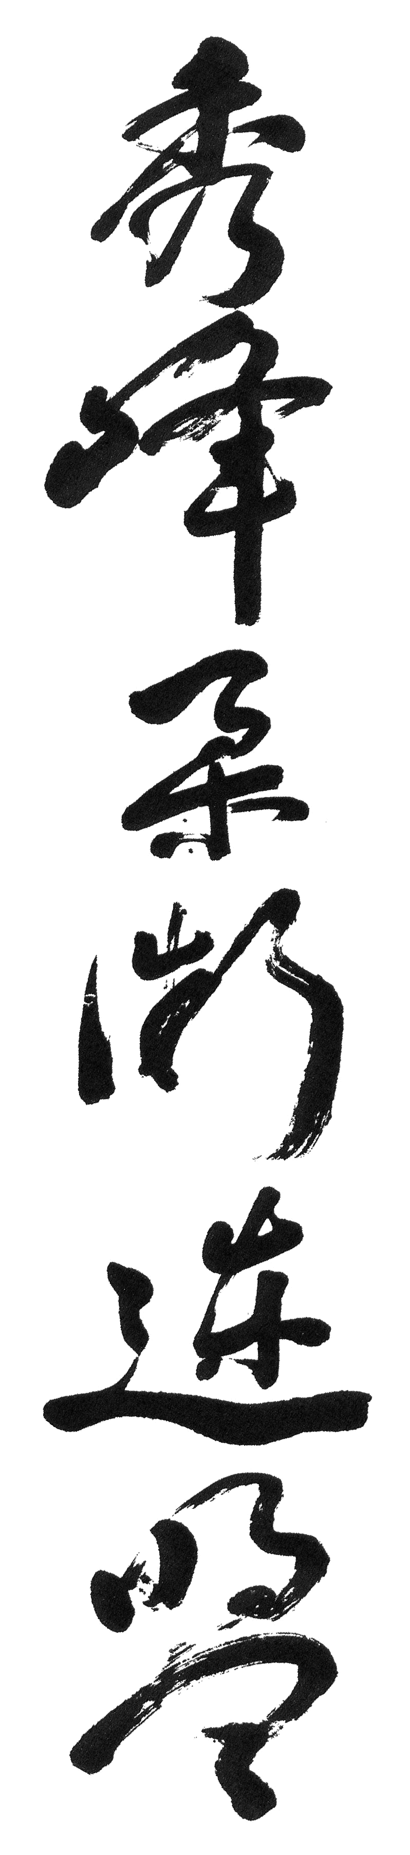
Red Belt (6th Kyu)

Half Shoulder Throws (2)

Body Drop (2)

Leg Throw

(A) Attacker's Left Leg Forward
(B) Attacker's Right Leg Forward

Dropping Full Shoulder

Back Hammer Lock

Back Scissors Throw (2)

Sweeping Loin

(A) Attacking
(B) Defending

Outside Hock

Drawing Ankle

Inside Hock

Stamp Throw

Palm Locks (2)

